Post Name Caption
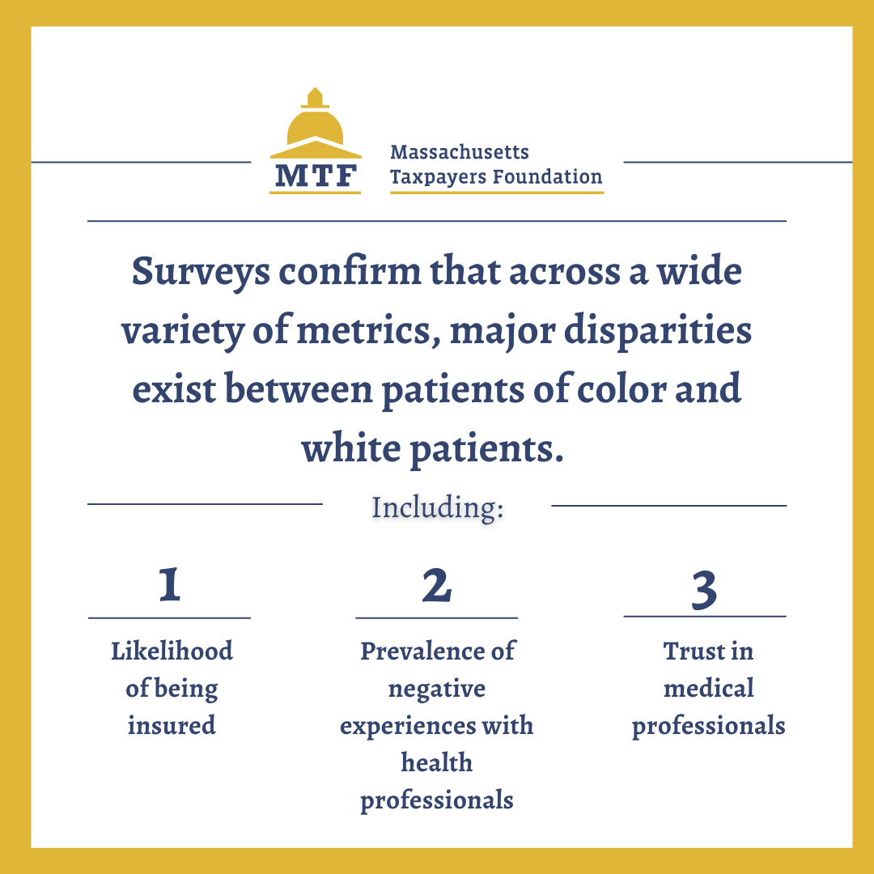 | Statistics LINKEDIN | Access to health care should ensure #equity for everyone. To learn about how Massachusetts can address these disparities, read our new report. #healthdisparities
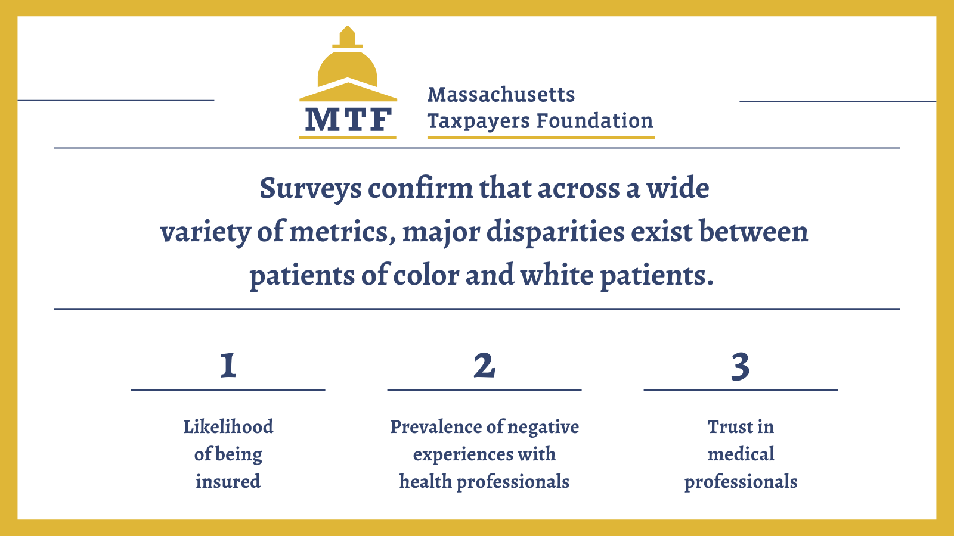 | Statistics TWITTER | Access to health care should ensure #equity for everyone. To learn about how Massachusetts can address these disparities, read our new report. #healthdisparities
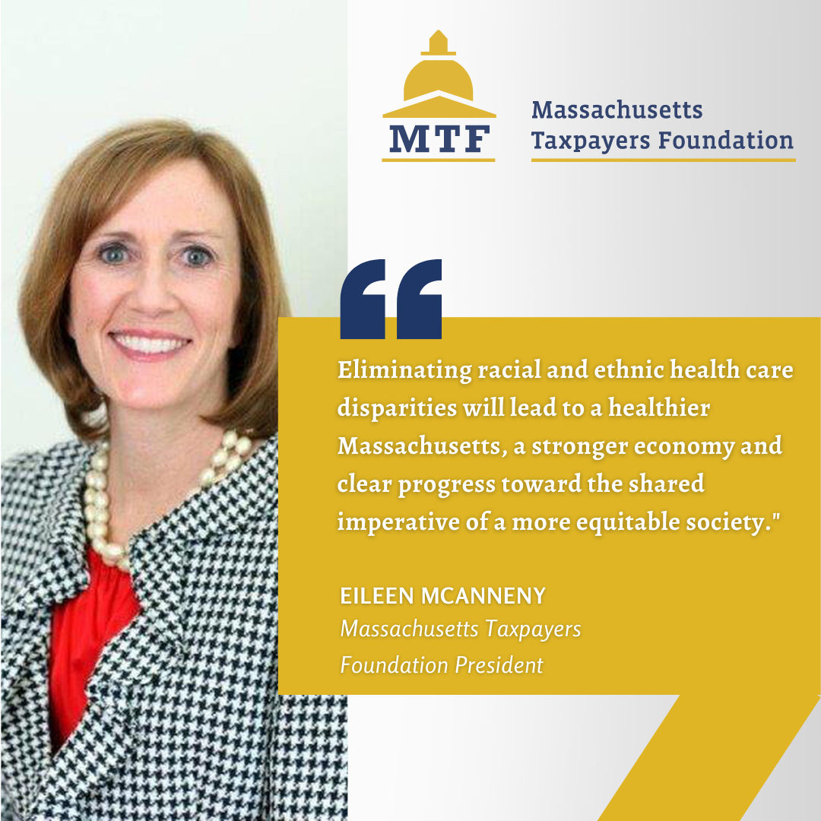 | Quote 1 LINKEDIN | As MTF President @emcanneny says, we can and must do more to boost #healthequity throughout Massachusetts. Read our new report now:
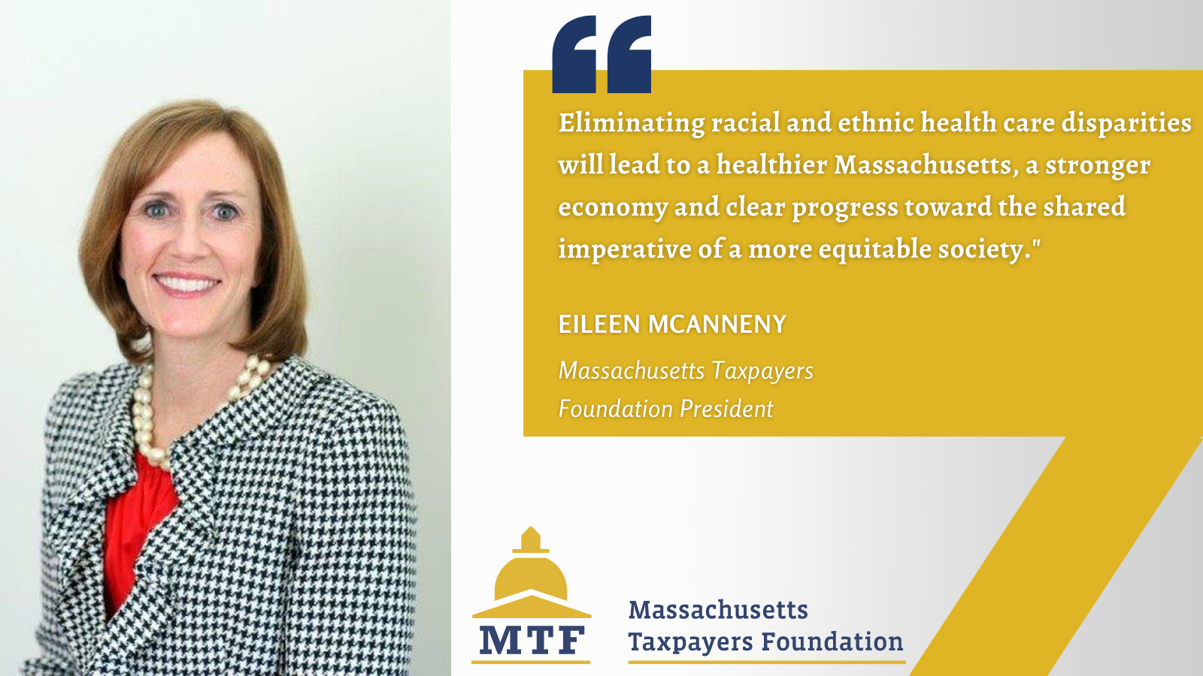 | Quote 1 TWITTER | As MTF President @emcanneny says, we can and must do more to boost #healthequity throughout Massachusetts. Read our new report now:
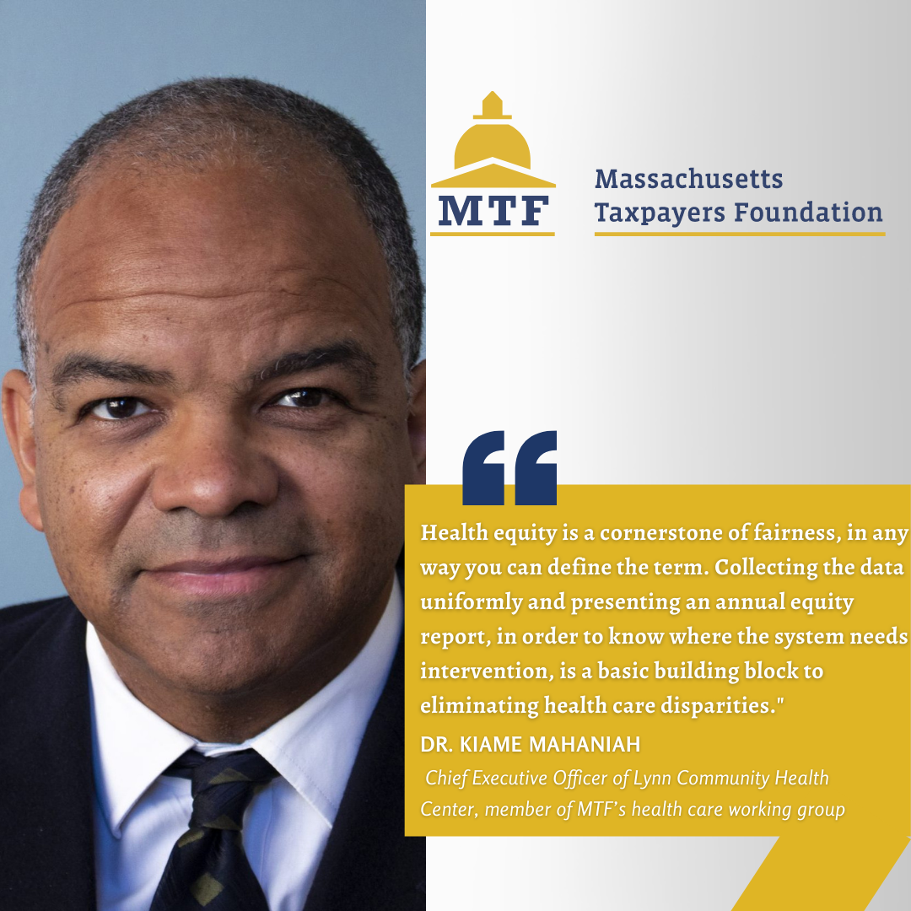 | Quote 2 LINKEDIN | As our new report makes clear, Massachusetts must take four concrete steps to bolster health care #equity. Learn more in our report now. Lynn Community Health Center
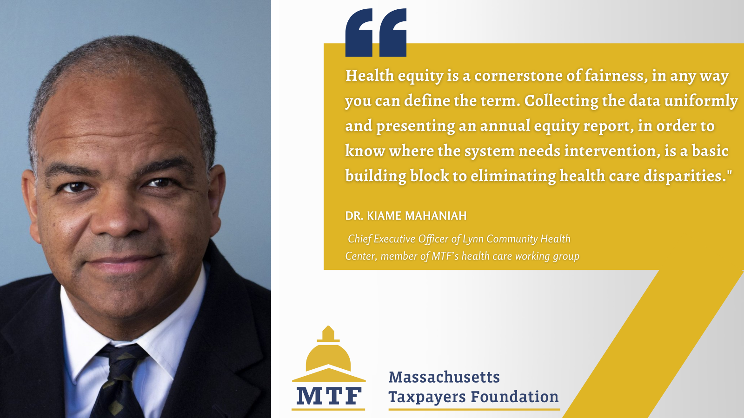 | Quote 2 TWITTER | As our new report makes clear, Massachusetts must take four concrete steps to bolster health care #equity. Learn more in our report now. @LynnCHC
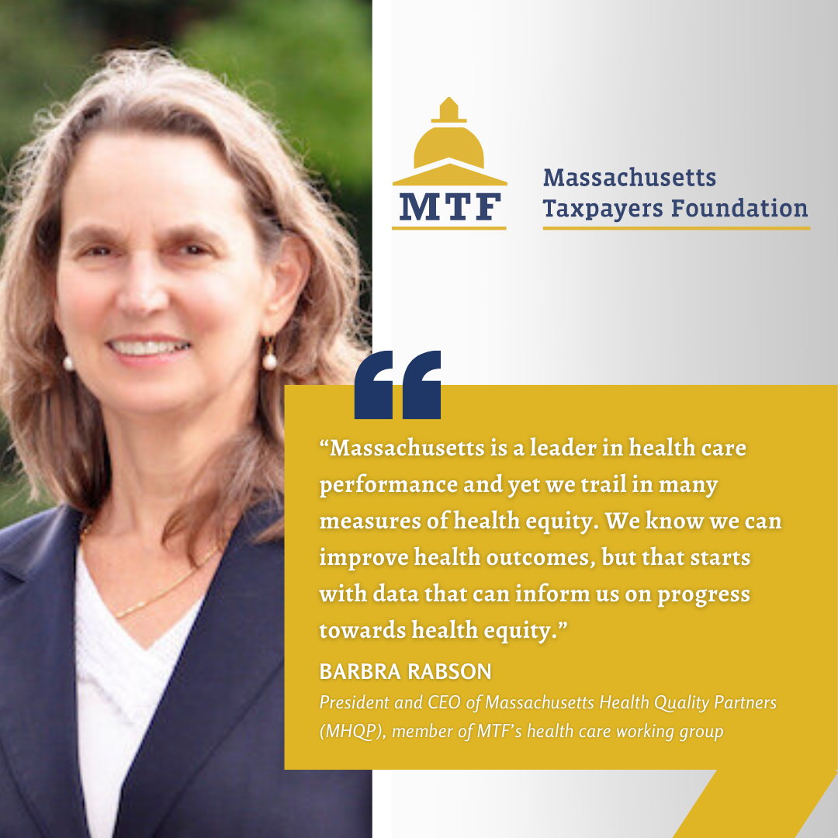 | Quote 3 LINKEDIN | To learn about how data makes a difference, read our new report now:
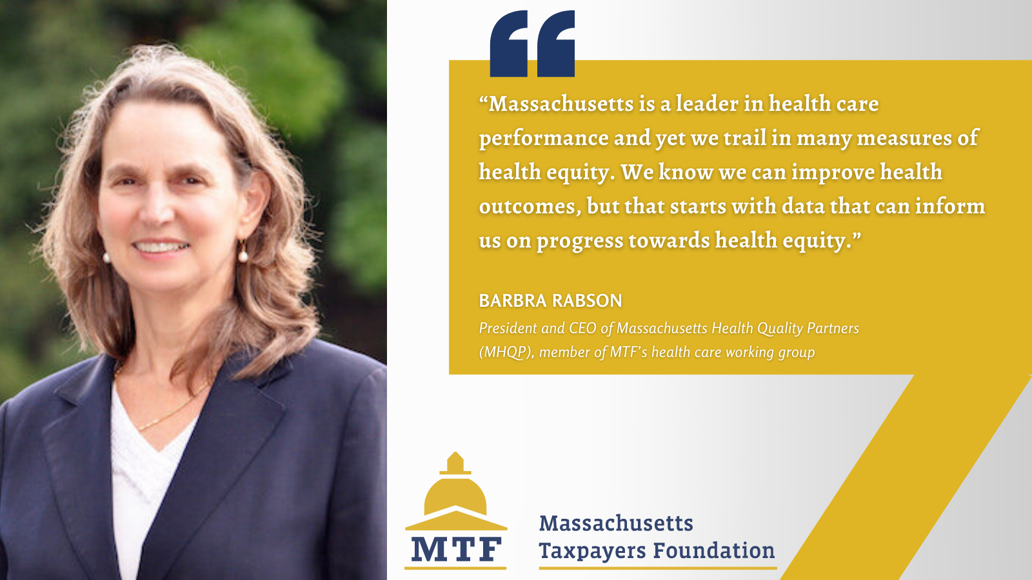 | Quote 3 TWITTER | As @MHQP President Barbra Rabson makes clear, data makes a difference. Read our new report now: #healthdisparities #HealthEquity
 | Quote 4 LINKEDIN | Dr. Rosa Colon-Kolacko reiterates the importance of inclusive healthcare, which we highlight in our new report. Read it here:
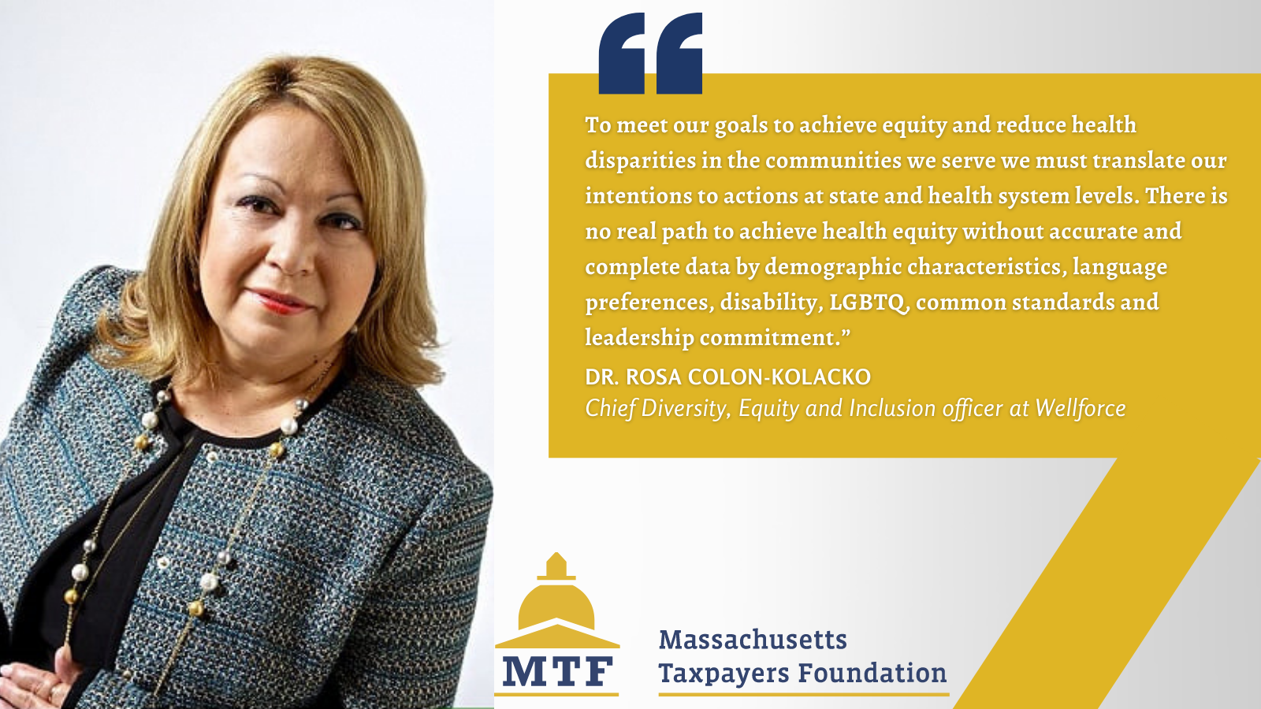 | Quote 4 TWITTER | Dr. Rosa Colon-Kolacko of @Wellforce reiterates the importance of inclusive healthcare, which we highlight in our new report. Read it here: . #healthdisparities #HealthEquity
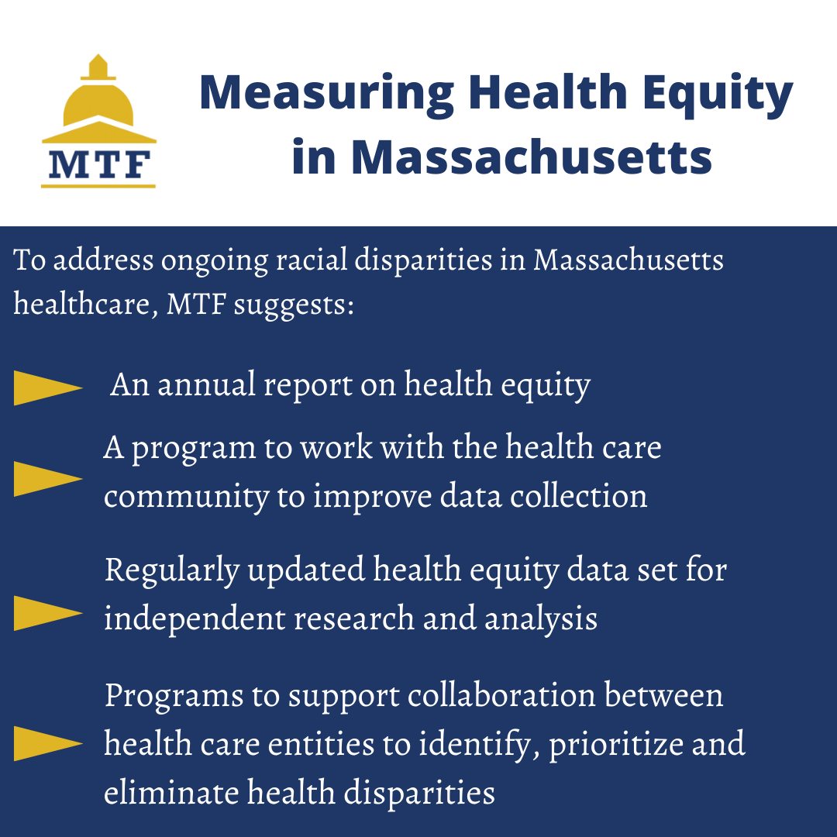 | Key Findings LINKEDIN | These are the steps we must take to make health care equitable for everyone in Massachusetts. Read our new report to learn more.
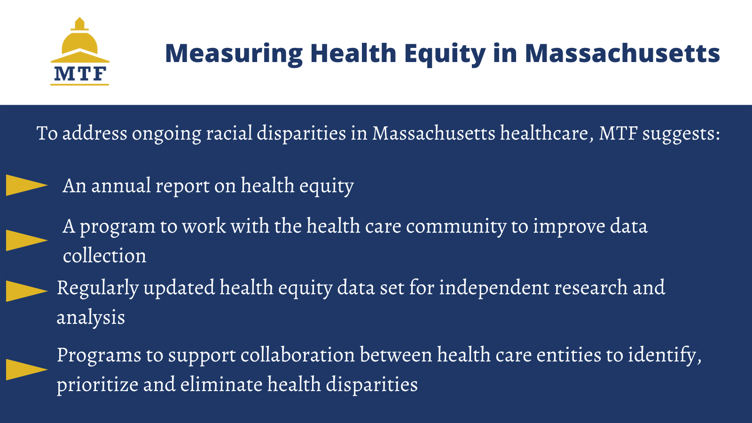 | Key Findings TWITTER | These are the steps we must take to make health care equitable for everyone in Massachusetts. Read our new report to learn more. #healthdisparities #HealthEquity

